India Head Office and Development Center
CB-40, Salt Lake City, Sector-1,
Kolkata-700 064, West Bengal, India
Phone: +91 33 2359 7240
Email: info@acumensofttech.com
Office USA
Phone: +1 818 237 0309
Email: info_us@acumensofttech.com

Office Canada
#406-4178 Dawson Street, Burnaby,
British Columbia, Canada
Phone: +1 778 330 7295


PROJECT PROPOSAL DOCUMENT

Doc Name: Proposal for Guru.in Website
Version 1.01 | Dated: September 6, 2012

DEVELOPMENT | DESIGN | SEO | CONSULTANCY
PROPOSAL FOR
GURU.IN SEARCH ENGINE SITE
Copyright © Acumen Consultancy Services Pvt. Ltd.
Table of Contents

1. Document Information 3
2. Owner’s List of Contacts 3
3. Document Revision History 3
4. Approval 3
5. Introduction 4
6. References 4
7. Definitions & Abbreviations 4
8. Requirement Analysis & System Design 4
9. Main Features and Functionalities 5
9.1. Site Viewer Functionalities: 5
9.2. Member User Functionalities: 9

Document Information

Document Version |  | 1.01
Prepared For:
Prepared By:
Name | Role | Date
Ashim Saha | CTO | 5-September-2012

Owner’s List of Contacts

Name | Email ID/Website | Designation
Kausik Sarkar | kausik@acumensofttech.com | Managing Director
Ashim Saha | ashim.saha@acumensofttech.com | CTO

Document Revision History
Version | Date of Release | Description | Author
1.01 | 6-9-2012 | Project Proposal | Ashim Saha

Approval

Version | Version Date | Prepared By | Reviewed By | Approved By
1.01 | 6-9-2012 | Ashim Saha

Introduction

The proposed website is search engines platform by which user can search not only by category location but also nearby like giving distance unit (km) and it also have glossary facility for a search. Users can register in the site as a member or as a company and can search according to particular category, location etc. Registered users can also act as franchisee and can be able to customize their profile with more category and keywords.

The website will be controlled by an admin management section.

References

Sl. No. | Name of the Document/Website | Date
1

Definitions & Abbreviations

Abbreviations | Definitions
- | -

Requirement Analysis & System Design

In this Phase details analysis of the site will be done. This phase will result High Level Design Document. Individual Screens will be explained in this document. As well as detail validation and business rules will be described in this document.

Main Features and Functionalities

The following types of users are identified in this system:

- Site viewer
- Registered Member
- Company registered user.
- Super administrator

Following are the user specific functional description in details:

Site Viewer Functionalities:

- Search according to particular category
  - Quick search
  - Search by Keywords
  - Alphabetical search
  - Search by Categories

Site viewers can search for particular category like Doctor, Travel, Restaurants, Bank etc by the above mentioned ways. The search result will list the places available in the system according to the search criteria. User can view the details of the desired category by clicking on each category in the list. User can search not only by category location but also nearby like giving Km, city/zip code and keyword. it also have glossary facility for a search.

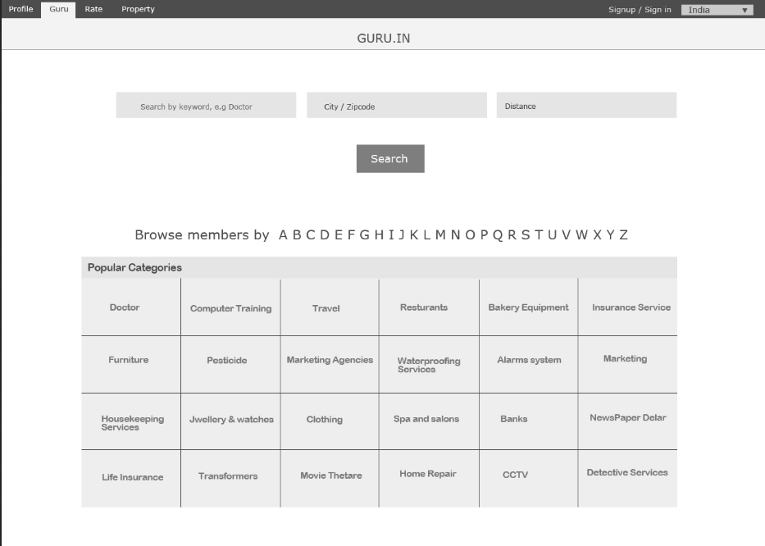

Start page

- View CMS pages
- About us
- Terms & Condition
- FAQ
- Contact us

Site visitors can view the content of the CMS pages and send query from the Contact us section to the site admin.

- User registration
- Member Registration
- Company Registration. *(part of future implementation) not in this scope of project.

The site viewers will be able to register to the site by filling up a registration form in the website. Users can register as an individual member or as a company by filling up a registration form. While registering as individual user there is option to choose language. In company registration has to choose their industry type from registration form.

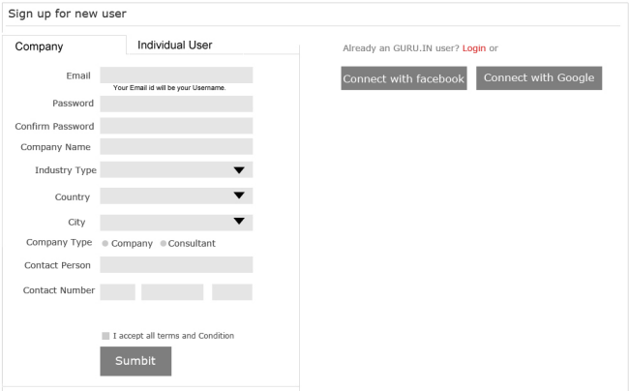

Individual User Registration

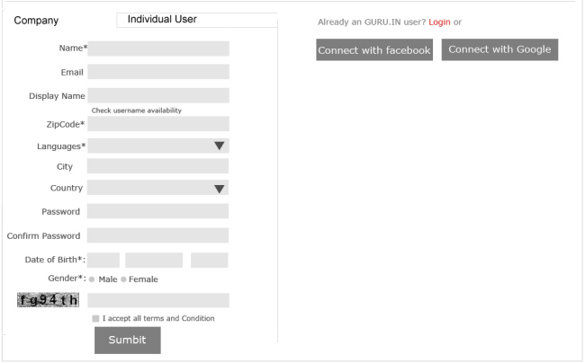

Company User Registration

- User authentication
  - User Sign in
  - Login Recovery

Registered members will be able to login to the site using their secure login credentials. System will restrict any type of unauthorized access or login attempt through unregistered username and password or sql injection etc. Error messages will be displayed in case of username and password mismatch and/or blank username and password.

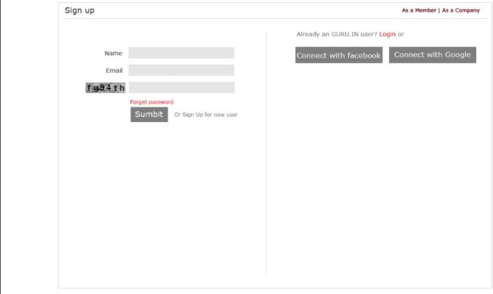

Site users will be able to retrieve his/her forgotten password from the forget password section.

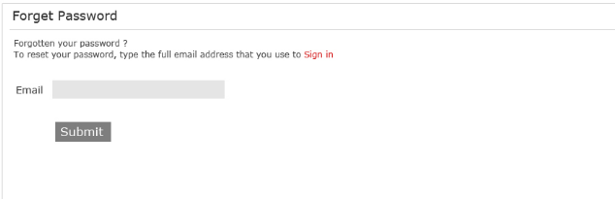

Forget Password

Member User Functionalities:
- User (artist) authentication
  - User login
  - Forget password

Registered Members can login to the site using secure login id and password, retrieve forgotten password by providing the registered email address.

- Listing Page

After proper registration registered members will reach to the Listing page immediately after signing in to the site. From listing page members can refine and filter their search criteria and also can save the search criteria.

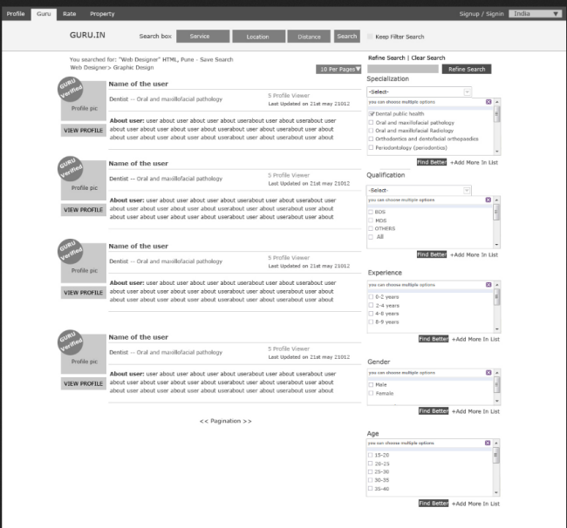

Listing Page

- Profile Management
  - Public Profile
  - Private Profile

Registered members have two types of profile Public Profile and Private Profile. In Private Profile members can be viewed their profile with confidential details (Email. phone) but in Public Profile members confidential details cannot be viewed by all.

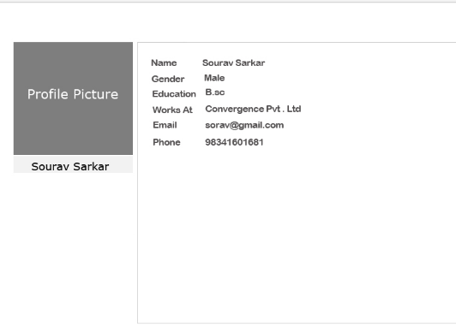

Private Profile

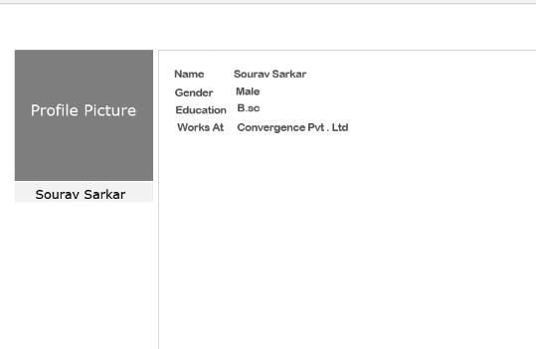

Public Profile

- Manage Account

Registered members have three type of Profile Management.

- Personal Profile
- Edit Profile
- Guru Profile
- Select Service name
- Select Category
- Select Location
- Select Medium
- Select Language

- Franchisee Profile
- Select Location
- Select Sub Domain Prefix
- Select Domain
- Select Theme
- Select HTML
- Save Search
- Send Message
- Report Abuse

Registered members can perform following tasks (*part of future implementation which is not in this scope of project.):

- Can listing 1 employees only.
- Can give ADS

Registered members will be able to manage own profile after login to the site. They can edit their Personal Details in their personal profile section.

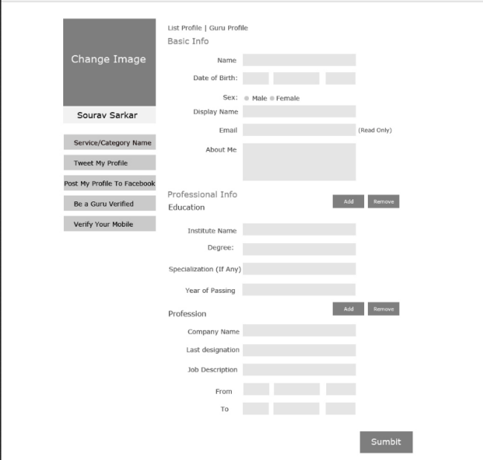

Edit Profile

Member User will be able to customize their profile broad way as Guru Profile user. As Guru Listing user they can customize their service details by selecting Name, Category, Location, Medium and Language. By saving and customization of profile details with more keywords user credentials can be come easily on the search result of the searching criteria and site visitors can be able to search more easily.

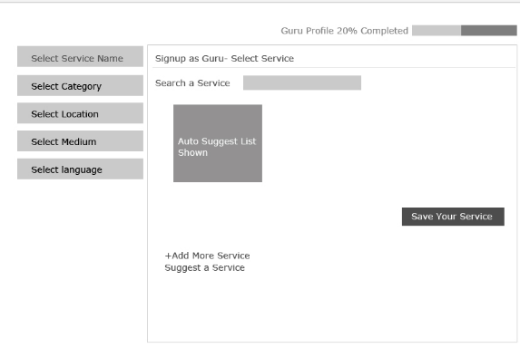

List as Guru page

Member User will be able to make their profile as a Franchisee user. Franchisee user can also be customize their profile details by selecting particular Location, Sub Domain Prefix, Domain, Theme, HTML .

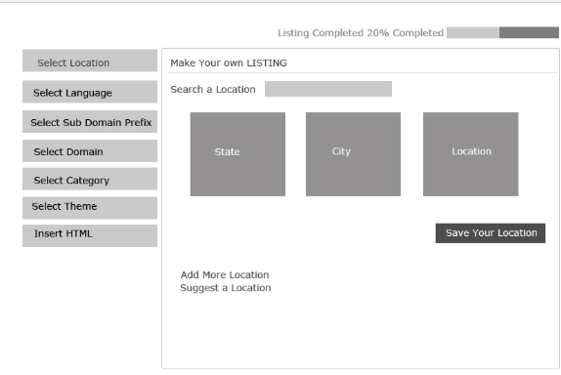

Franchisee page

Registered Members will be able to save their search criteria from save Search page.

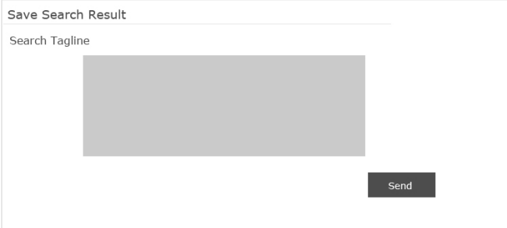

Save Search Page

Registered Members will be able to send messages to other member from Message to Member page.

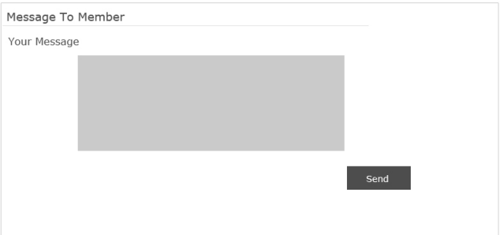

Message to Member Page

Registered Members will be able to send abusive message from Report Abuse page.

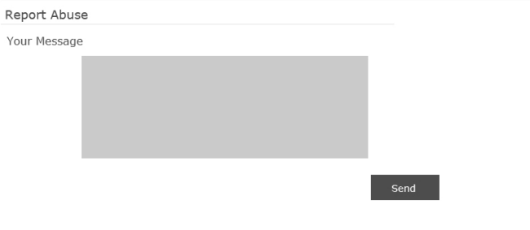

Report Abuse Page

  - Company User Functionalities:

- User (artist) authentication
  - User login
  - Forget password

Registered Company user can login to the site using secure login id and password, retrieve forgotten password by providing the registered email address.

- Listing Page

After proper registration registered company will reach to the Listing page immediately after signing in to the site. From listing Page Company user can refine and filter their search criteria and also can save the search criteria.

Company Listing Page

- Profile Management

Company registered user gets two type of facilities from the site i) Premium service facility, ii) Free service facility. Company registered user can perform following tasks *(part of future implementation which is not in this scope of project.):

  - list 10 employees on payment basis
  - list 5 services
  - have some domain
  - give ADS

